

**Product Dissection Of YouTube**

### **Company Overview:**

YouTube is a Globally recognized video-sharing platform headquartered in San Bruno, California.YouTube was founded in February 2005 by three former PayPal employees: Steve Chen, Chad Hurley, and Javed Karim.YouTube allows users to upload, view, rate, share, add to playlists, report, comment on videos, and subscribe to other users.

As a key player in digital entertainment, YouTube has profoundly influenced video consumption habits worldwide. This platform quickly gained popularity due to its simplicity and ability to host a wide variety of content. In November 2006 Google acquired YouTube, this acquisition significantly bolstered YouTube’s resources and capabilities, allowing it to scale rapidly and integrate with Google’s vast advertising network.

### **Product Dissection and Real-World Problems Solved by YouTube:**

YouTube, the world’s largest video-sharing platform, has profoundly influenced various aspects of modern society.YouTube has grown from a simple video-sharing site into a powerful tool that shapes entertainment, education, social interactions, and even global culture. One of YouTube’s most significant impacts is the democratization of content creation. Before YouTube, creating and distributing video content was largely restricted to those with access to significant financial and technical resources, such as television networks and film studios. YouTube changed this landscape by allowing anyone with an internet connection and a camera to create and share videos with a global audience.

YouTube offers numerous opportunities for creators (video makers) to monetize their channels, transforming their passions and creative efforts into profitable ventures.YouTube offers a variety of monetization features that enable creators to earn revenue from their content. Monetization features include Super Thanks, Ad Revenue, Channel Memberships,

Super Chat and Super Stickers, YouTube Premium Revenue, etc.YouTube's Partner Program and Super Chat feature further empower creators to monetize their content and connect with their audience in new and innovative ways.

YouTube’s engagement features including likes, comments, shares, and subscriptions have transformed how users interact with video content. Moreover, YouTube serves as a powerful tool for connecting people across different geographical locations, fostering relationships, and building communities.YouTube has revolutionized access to education by making learning materials available to anyone with an internet connection, eliminating traditional barriers to education. This democratization of knowledge has profound implications for learners worldwide, providing unprecedented opportunities for personal and professional

growth.

In conclusion, YouTube's innovative product offerings have revolutionized the way people consume and interact with video content, addressing a wide array of real-world challenges. From democratizing content creation and enhancing discovery to providing significant economic opportunities and fostering social impact, YouTube empowers creators to share their stories and connect with global audiences. As a dynamic platform, YouTube continues to shape the digital landscape, driving meaningful change and inspiring countless individuals and communities worldwide. Through its ongoing evolution and commitment to innovation, YouTube remains at the forefront of the digital revolution, transforming lives and society in profound ways.

**Case Study: Real-World Problems and YouTube's Innovative Solutions**

YouTube has not only transformed the landscape of digital content but also provided innovative solutions to a variety of real-world problems. From empowering individual creators to fostering global communities, YouTube addresses numerous challenges in unique and impactful ways.

#### **Problem 1: Disconnect in Digital Relationships**

**Real-World Challenge:** In today’s digital world, maintaining meaningful relationships can be challenging. The rise of online interactions often leads to disconnection and superficial connections.YouTube, however, has developed several innovative features and strategies to bridge these gaps and foster genuine, meaningful relationships among users.YouTube faces several challenges, including cultural and language barriers, as well as issues related to user engagement, etc..

**YouTube's Solution:**

YouTube addresses the disconnect in digital relationships by fostering meaningful interactions through its community features, real-time engagement tools, membership options, and support for cultural exchange. By facilitating deeper connections between creators and viewers, YouTube not only enhances the user experience but also promotes a sense of belonging and community.YouTube also allows its users to share their emotions, and experiences in a more impactful manner and also YouTube offers features like subtitles and translations to help users effectively understand video content. Through these innovative solutions, YouTube continues to bridge the gaps in digital relationships, making online interactions more meaningful and impactful.

#### **Problem 2: Information Overload**

**Real-World Challenge:** The Overwhelming amount of videos and content available on the platform, makes it difficult for users to navigate and find relevant content amidst the vast array of options.

**YouTube's Solution:**

YouTube addresses this issue through its sophisticated recommendation system, YouTube’s recommendation algorithm analyzes user behavior and preferences to suggest videos that are likely to be interesting to each user. Also, users can subscribe to a channel they are interested in, YouTube analyzes how users interact with content and provides features such as likes, comments, shares, and subscriptions to gauge their interests. Additionally, YouTube continually strives to simplify its platform, ensuring that users can navigate and use it with ease.

#### **Problem 3: Finding a Niche for Creativity**

**Real-World Challenge:** Many aspiring individuals encounter difficulties in discovering appropriate platforms where they can exhibit their talents and potentially capitalize on their abilities.

**YouTube's Solution:**

YouTube provides a dynamic platform for individuals to showcase their talents, connect with audiences worldwide, and explore diverse monetization avenues. By leveraging the platform's vast reach, interactive features, and monetization options, creators can turn their passion into a fulfilling career while entertaining, educating, and inspiring millions of viewers around the globe. Creators can upload videos from various genres like Art, Music, Lifestyle, Tech, and more, offering a wide array of content for viewers to explore and enjoy. Some of YouTube’s monetization features, such as ads, channel memberships, and Super Chat donations, provide creators with opportunities to generate revenue from their content and engage with their audience in meaningful ways.

#### **Problem 4: Limited Personal Branding**

**Real-World Challenge:** In the Digital era, establishing a distinctive online identity can be challenging.

**YouTube’s Solution:**

YouTube provides creators with robust customization options, including profile pictures, channel banners, descriptions, and customized sections. These features enable creators to establish a strong visual identity, communicate their brand story, and engage with their audience effectively. By leveraging these customization opportunities, creators can create a compelling and cohesive channel experience that resonates with viewers and helps them stand out in the competitive landscape of YouTube.

#### **Conclusion:**

As YouTube has evolved from a mere video-sharing platform into a global phenomenon, it has demonstrated a remarkable ability to adapt to real-world challenges and provide innovative solutions. Through its emphasis on fostering authentic connections, delivering tailored content experiences, empowering creative expression, and enabling personal branding, YouTube has effectively addressed a multitude of obstacles encountered by users in the digital sphere. This case study showcases YouTube's dedication to user-centric approaches and continuous innovation, cementing its position as a pioneer in the online domain and revolutionizing the landscape of content consumption and creation on the internet.

### **Top Features of YouTube:**

1. **Video Uploading & Sharing**: Users can upload videos in various formats and resolutions. YouTube's video uploading and sharing capabilities are designed to accommodate a wide range of content genres, each with its own unique audience and community.
2. **Channel Customization Options:** Users can customize their channel by adding a proper profile picture, channel description, channel banner, channel trailer, and setting a custom URL.
3. **Monetization Options**: YouTube provides several monetization options for creators, enabling them to earn money from their content. These options cater to different types of content and audience engagement, helping creators turn their passion into a viable source of income. Important monetization features include Ad revenue, Super Thanks, channel memberships, and merchandise sales.
4. **Community Features:** YouTube offers a variety of Community features designed to enhance the interaction between creators and their audience, fostering a sense of community engagement. Some of the community features include Community tabs, live chat, Super Chat, and Super Stickers.
5. **Collaboration & Cross-promotion features:** Collaboration and cross-promotion features on YouTube set it apart from other platforms by fostering a sense of community and allowing creators to leverage each other's audiences for mutual benefit.YouTube's collaboration and cross-promotion features not only differentiate it from other platforms but also contribute to its vibrant and diverse creator community, enriching the viewing experience for audiences worldwide.
6. **Analytics Feature**: YouTube's analytics features empower creators to gain deep insights into their audience behavior and discover trending topics globally. Most importantly Creators can analyze the performance of their channel including metrics such as watch time, audience demographic data, audience gender, and revenue data. This feature enables them to plan their content strategically and also allows them to take necessary actions based on these insights.
7. **Content Discovery:** YouTube facilitates its audience in discovering a diverse array of content through its search feature, homepage, trending section, and subscription feeds. This user-friendly navigation system enables users to explore the platform effortlessly.
8. **Content Moderation & Safety:** Content Moderation & Safety on YouTube is ensured through the implementation of robust community guidelines and copyright policies. These measures are put in place to maintain a safe and respectful environment for users and creators alike. Additionally, YouTube empowers its users by providing report features, allowing them to flag videos, comments, or entire channels that they believe violate YouTube's community guidelines or copyright policies.
9. **Recommendation System:** YouTube’s recommendation system suggests personalized videos to its users. This is based on their viewing history, search, history, preferences, and engagement patterns(including like, share, comments & subscribes).YouTube continually enhances the relevance and effectiveness of its recommendations, providing users with a compelling and personalized viewing experience.
10. **Accessibility Features:**  YouTube's accessibility features aim to make content more inclusive and accessible to all users, regardless of their abilities or circumstances. Some of the accessibility options include auto-generated captions, custom subtitles, and automatic translations.

**Schema Description:**

YouTube’s schema design typically includes tables for Users, Videos, Comments, Likes, Subscriptions, and Playlists, playlist videos, etc each with relevant attributes and relationships. Users can upload Videos, which can receive Comments and Likes. Users can subscribe to other Users' channels and create Playlists to organize Videos. Different entities present on YouTube are:

**Users:** Representing individuals who use the platform. This entity stores information such as usernames, passwords, email addresses, profile pictures, etc.

User entity includes the following attributes:

* User Id(Primary Key)
* User name
* Email
* Password
* Date Joined
* Last Login
* Profile picture url
* Bio

**Videos:** Content uploaded by users, containing attributes like titles, descriptions, upload dates, view counts, etc. Its important attributes are:

* video_id
* user_id
* title
* description
* url
* thumbnail_url
* upload_date
* views

**Comments:** User-generated responses to videos, including attributes like text content, and timestamps. Its attributes are:

* comment_id
* video_id
* User_id
* text
* timestamp
* parent_comment_id

**Likes:** It serves as a metric of user engagement and content appreciation. Its important attributes are:

* like_id
* user_id
* video_id
* like_date

**Subscriptions**: Relationships between users, indicating that one user follows another user's channel for updates. its important attributes are:

* subscription_id
* subscriber_user_id
* channel_id
* subscription_date

**Playlists**: Collections of videos curated by users, allowing them to group related content together. Its important attributes are:

* plalist_id
* user_id
* name
* description
* creation_date

**PlaylistVideos**: This entity allows a single video to be part of multiple playlists and a single playlist to contain multiple videos. It helps in organizing videos into curated collections, enhancing user experience and content discoverability. Its attributes are:

* playlist_video_id
* Playlist_id
* video_id
* added_date

**Categories:** In YouTube, categories are used to classify and organize content, making it easier for users to discover videos based on their interests. Its attributes are:

* category_id
* name
* description

**Video tags:** This entity is used to manage the relationship between videos and tags. Tags are keywords or phrases that describe the content of a video, making it easier for users to find videos through searches and recommendations. Its attributes are:

* video_tag_id
* video_id
* tag

**Relationships are:**

* **Users upload videos:** Each user can upload multiple videos from different genres like Arts, Music, Cooking, Tech, etc…
* **Users create channels:** Users can create their own YT channel.
* **Users can create engagement on YouTube:** Users can create engagement on YouTube through various activities like commenting, liking/disliking, subscribing, and sharing.
* **Users create Playlists:** Each user can create multiple playlists.
* **Users can add videos to Playlists:** Users can add videos to a playlist directly from the video page by clicking the "Save" button below the video and selecting an existing playlist or creating a new one.
* **Categories**: Categories provide broad classifications, helping users navigate through general topics.
* **Video Tags**: It offers detailed, specific descriptors, enhancing searchability and recommendations within those broad categories.

**ER Diagram:** Let's construct an ER diagram that vividly portrays the relationships and attributes of the entities within the YouTube schema. This ER diagram will serve as a visual representation, shedding light on the pivotal components of YouTube's data model. By employing this diagram, you'll gain a clearer grasp of the intricate interactions and connections that define the platform's dynamics.

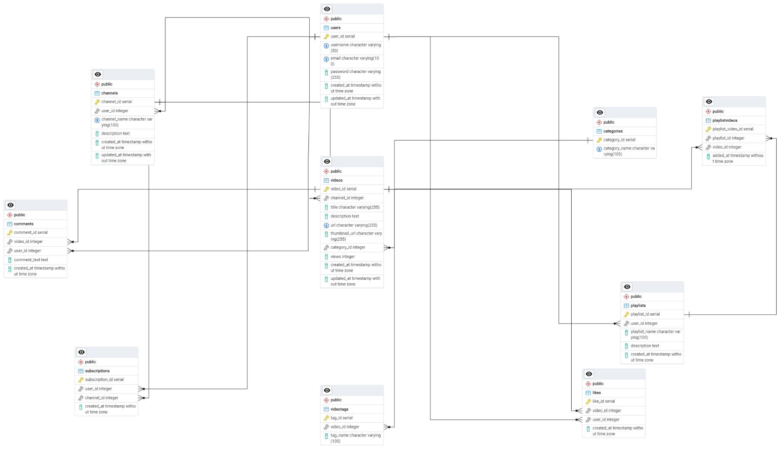

### **Conclusion**

In this project, We explored YouTube's schema and how it manages user interactions, videos, comments, likes, tags, categories, playlists, and subscriptions. This structured framework ensures seamless content sharing and engagement, key factors driving YouTube's immense popularity and success online.

YouTube isn't just a platform it's a cultural phenomenon shaping how we consume and create video content. With features like personalized recommendations and live streaming, YouTube remains at the forefront of digital entertainment.

Looking forward, YouTube's commitment to accessibility and user-centricity ensures its continued relevance and influence in shaping the future of online media. It's more than just a website, it's a global community, empowering individuals and businesses alike to connect, create, and share their stories with the world.